Aim
To compute the Matrix Block Sum for a given matrix mat, where each element in the result matrix is the sum of all elements within a distance K from that element (in all directions), using an efficient 2D Prefix Sum technique.
Algorithm:
- Read matrix dimensions m (rows) and n (columns).
- Create a result matrix ans[m][n].
- Create a prefix sum matrix t[m+1][n+1] initialized with 0.
- Build the prefix sum matrix:
- For each cell (i, j):
- t[i][j] = t[i-1][j] + t[i][j-1] + mat[i-1][j-1] - t[i-1][j-1]
- For every element (i, j) in the matrix:
- Determine the block boundaries within distance K:
r1 = max(0, i-K)
c1 = max(0, j-K)
r2 = min(m-1, i+K)
c2 = min(n-1, j+K)
- Convert to prefix sum indexing (+1 shift).
- Compute block sum using inclusion–exclusion formula:

program:
class Solution {
public int[][] matrixBlockSum(int[][] mat, int K) {
int m = mat.length;
int n = mat[0].length;

int[][] ans = new int[m][n];

int[][] t = new int[m + 1][n + 1];

for (int i = 1; i < t.length; i++) {
for (int j = 1; j < t[0].length; j++) {
t[i][j] = t[i - 1][j] + t[i][j - 1] + mat[i - 1][j - 1] - t[i - 1][j - 1];
}
}

for (int i = 0; i < m; i++) {
for (int j = 0; j < n; j++) {
int r1 = Math.max(0, i - K) + 1;
int c1 = Math.max(0, j - K) + 1;
int r2 = Math.min(m, i + K + 1);
int c2 = Math.min(n, j + K + 1);
ans[i][j] = t[r2][c2] - t[r1 - 1][c2] - t[r2][c1 - 1] + t[r1 - 1][c1 - 1];
}
}

return ans;
}
}
Output:
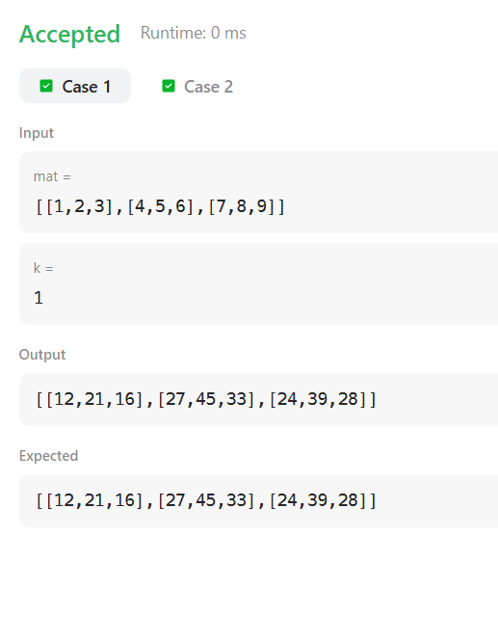

Result:
For the given program, the matrix block sum is calculated using a distance K around each element.

Aim
To rotate the elements of a given matrix layer by layer (ring by ring) in the anti-clockwise direction by r rotations and display the rotated matrix.

Algorithm
- Read matrix dimensions m (rows), n (columns), and number of rotations r.
- Store matrix elements in a 2D list.
- Determine the number of layers:
- layers = min(m, n) / 2
- For each layer:
  - Extract elements of the current ring in order:
    - Top row (left → right)
    - Right column (top → bottom)
    - Bottom row (right → left)
    - Left column (bottom → top)
- Compute effective rotations:
- rot = r % number_of_elements_in_layer
- Rotate the extracted list anti-clockwise by rot positions.
- Place the rotated elements back into the matrix in the same ring order.
- Repeat for all layers.
- Print the final rotated matrix.
Program
import java.io.*;
import java.util.*;
import java.util.stream.*;
import static java.util.stream.Collectors.toList;

class Result {

public static void matrixRotation(List<List<Integer>> matrix, int r) {

int m = matrix.size();
int n = matrix.get(0).size();

int layers = Math.min(m, n) / 2;

for (int layer = 0; layer < layers; layer++) {

List<Integer> elements = new ArrayList<>();

int top = layer;
int bottom = m - 1 - layer;
int left = layer;
int right = n - 1 - layer;

// Top row
for (int i = left; i <= right; i++)
elements.add(matrix.get(top).get(i));

// Right column
for (int i = top + 1; i <= bottom - 1; i++)
elements.add(matrix.get(i).get(right));

// Bottom row
for (int i = right; i >= left; i--)
elements.add(matrix.get(bottom).get(i));

// Left column
for (int i = bottom - 1; i >= top + 1; i--)
elements.add(matrix.get(i).get(left));

int len = elements.size();
int rot = r % len;

// Rotate anti-clockwise
List<Integer> rotated = new ArrayList<>();
rotated.addAll(elements.subList(rot, len));
rotated.addAll(elements.subList(0, rot));

int idx = 0;

// Put back Top row
for (int i = left; i <= right; i++)
matrix.get(top).set(i, rotated.get(idx++));

// Right column
for (int i = top + 1; i <= bottom - 1; i++)
matrix.get(i).set(right, rotated.get(idx++));

// Bottom row
for (int i = right; i >= left; i--)
matrix.get(bottom).set(i, rotated.get(idx++));

// Left column
for (int i = bottom - 1; i >= top + 1; i--)
matrix.get(i).set(left, rotated.get(idx++));
}

// Print matrix
for (List<Integer> row : matrix) {
for (int val : row) {
System.out.print(val + " ");
}
System.out.println();
}
}
}

public class Solution {
public static void main(String[] args) throws IOException {

BufferedReader bufferedReader =
new BufferedReader(new InputStreamReader(System.in));

String[] firstInput =
bufferedReader.readLine().trim().split(" ");

int m = Integer.parseInt(firstInput[0]);
int n = Integer.parseInt(firstInput[1]);
int r = Integer.parseInt(firstInput[2]);

List<List<Integer>> matrix = new ArrayList<>();

for (int i = 0; i < m; i++) {
matrix.add(
Stream.of(bufferedReader.readLine().trim().split(" "))
.map(Integer::parseInt)
.collect(toList())
);
}

Result.matrixRotation(matrix, r);

bufferedReader.close();
}
}
Output
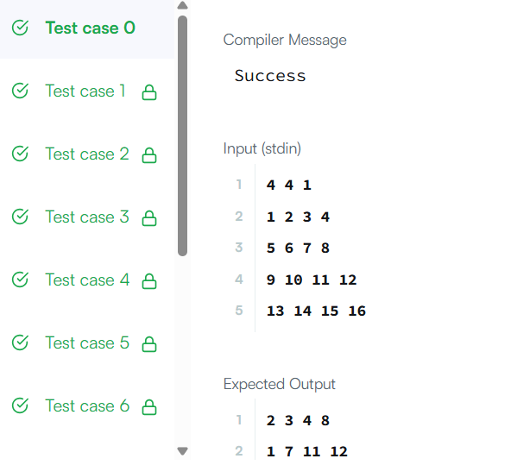

Result
The program successfully rotates each layer of the matrix anti-clockwise by the specified number of rotations and prints the final transformed matrix.

